ACCIPITER Ti  WARRANTY  ALL ECCO MACHINE SOUND SUPPRESSORS (SILENCERS) CARRY A LIMITED LIFETIME WARRANTY AGAINST DEFECTS IN MATERIAL OR WORKMANSHIP, OR FAILURES THAT OCCUR DURING NORMAL, APPROVED USE OF THE SUPPRESSOR. ABUSE IS NOT COVERED, INCLUDING BUT NOT LIMITED TO USE OF ECCO MACHINE SUPPRESSORS THAT ARE NOT FULL AUTO RATED ON MACHINE GUNS, USE OF ECCO MACHINE SUPPRESSORS WITH CARTRIDGES OR BARREL LENGTHS NOT APPROVED FOR THE MODEL, BAFFLE STRIKES RESULTING FROM IMPROPER MOUNTING OR FAILURE TO SECURE THE SUPPRESSOR, OR DAMAGE CAUSED BY THE END USER ATTEMPTING TO SERVICE THE SUPPRESSOR. DETERMINATIONS ARE AT THE SOLE DISCRETION OF ECCO MACHINE. ECCO MACHINE ASSUMES NO RESPONSIBILITY OR LIABILITY FOR ANY DAMAGE TO WEAPONS OR INJURY TO PERSONS RESULTING FROM ANY COMBINATION OF IMPROPER USE OF SUPPRESSORS AND FAILURE TO OBSERVE PROPER FIREARM SAFETY, INCLUDING PROTECTIVE EQUIPMENT.  FOR QUESTIONS, SERVICE OR REPAIR, CONTACT:  ECCO MACHINE  37245 QUAIL DR.  ELIZABETH, CO 80107  303-646-5202  Info@ECCOMachine.net | ACCIPITER Ti  CENTERFIRE RIFLE SUPPRESSOR  BY  ECCO MACHINE  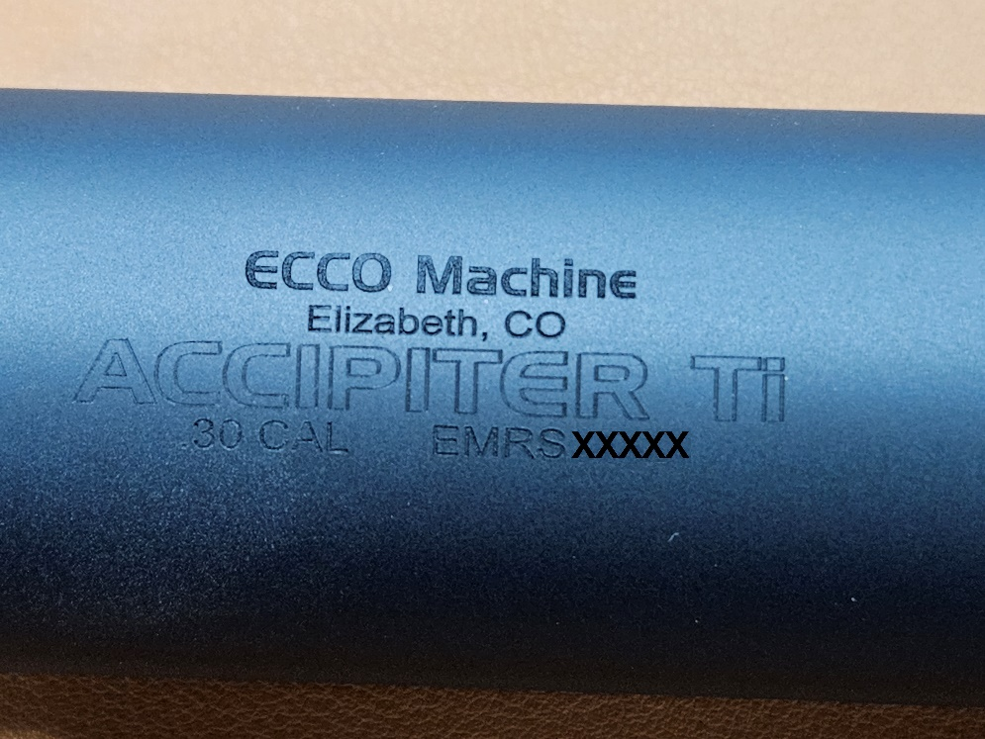
ABOUT THE ACCIPITER Ti RIFLE SUPPRESSOR  The Accipiter Ti is a lightweight heavy duty suppressor meant for use on full power and magnum rifles. It is made entirely from fusion TIG welded 6Al-4V Titanium.  The Accipiter Ti is rated for all rifle cartridges using up to 100 grain powder charges. It is rated for full auto use, but temperature should be monitored; if the external temperature of the suppressor exceeds 800°F in atmosphere, the titanim may be embrittled. Evidence of overheating voids the suppressor warranty.  USING THE ACCIPITER Ti  The Accipiter Ti is a 1.375-24 Bravo (H.U.B.) threaded suppressor. It will accept any industry standard 1.375-24 Bravo mount or adapter, which may also be referred to as “Omega 300”, “Hybrid” or sometimes “ASR”. Accipiter has a large enough blast chamber to accommodate every mounting system we are aware of. Open tine flash hider muzzle devices are not recommended for heavy firing schedules. Muzzle brake muzzle device are best, and sometimes assist with suppression as well as protecting the blast baffles from the worst of the ejecta and hot gas exiting the muzzle.  Under no circumstances are crush washers permissible for mounting direct thread suppressors, or for installation of a suppressor muzzle device. Direct contact with the barrel shoulder or precision shims/washers is mandatory for proper axial alignment.  Be attentive to the combinations of suppressor and muzzle device, ensure that your muzzle device is compatible with your host bore size. Firing an oversize bullet through a muzzle device is likely to damage the muzzle device and the suppressor.  The mating surface of both the mount/adapter and barrel or muzzle device should be wiped clean of debris and carbon before installation. Debris can damage parts by abrasion/galling. Additionally, the mating surface aligns the suppressor, so debris caught in the mating surface could cause misalignment or loosening of the suppressor, both of which can result in baffle strikes. | As with any suppressor, be sure to sufficiently torque the suppressor so that it does not come loose during firing, causing baffle strikes  SERVICING THE ACCIPITER Ti  The Accipiter Ti is not a user-serviceable suppressor. It is fully fusion TIG welded tubeless type suppressor constructed entirely of 6Al-4V titanium, so manual cleaning of individual baffles is not possible. You can use any prescribed method for cleaning sealed suppressors, such as solvent baths or ultrasonic cleaning.  SUPPRESSOR RATINGS  Magnum rifle and full auto (not continuous belt fed full auto fire/repeated back-to-back full auto magazine dumps).  -80-100 gr cartridges (RUMs, .338 Lapua, etc) 22” & longer barrel  -60-80 gr cartridges 18” & longer barrel  -35-60 gr. Cartridges 10” & longer barrel  -Under 35 gr cartridge no barrel restriction  Although approved for all cartridges up to .300 Remington Ultra Magnum, use of .22 short, long or long rifle is not recommended, nor is the use of any cast lead bullets.  Muzzle brake muzzle devices are required with high velocity rifle cartridges being fired from 12” or shorter barrels.

