CARACAL  WARRANTY  ALL ECCO MACHINE SOUND SUPPRESSORS (SILENCERS) CARRY A LIMITED LIFETIME WARRANTY AGAINST DEFECTS IN MATERIAL OR WORKMANSHIP FOR FAILURES THAT OCCUR DURING NORMAL, APPROVED USE OF THE SUPPRESSOR. ABUSE IS NOT COVERED, INCLUDING BUT NOT LIMITED TO USE OF ECCO MACHINE SUPPRESSORS THAT ARE NOT FULL AUTO RATED ON MACHINE GUNS, USE OF ECCO MACHINE SUPPRESSORS WITH CARTRIDGES OR BARREL LENGTHS NOT APPROVED FOR THE MODEL, BAFFLE STRIKES RESULTING FROM IMPROPER MOUNTING OR FAILURE TO SECURE THE SUPPRESSOR, OR DAMAGE CAUSED BY THE END USER ATTEMPTING TO SERVICE THE SUPPRESSOR. DETERMINATIONS ARE AT THE SOLE DISCRETION OF ECCO MACHINE. USE OF FIREARMS HAS INHERENT RISKS AND WE HAVE NO CONTROL OVER THE OTHER PARTS, ASSEMBLIES AND CONSUMABLES THAT MAY BE USED IN CONJUNCTION WITH OUR PRODUCTS; AS SUCH, ECCO MACHINE BEARS NO RESPONSIBILITY FOR ANY INJURY OR LOSS.  FOR QUESTIONS, SERVICE OR REPAIR, CONTACT:  ECCO MACHINE  37245 QUAIL DR.  ELIZABETH, CO 80107  303-646-5202  Info@ECCOMachine.net | CARACAL  5.7mm CALIBER SUPPRESSOR  BY  ECCO MACHINE  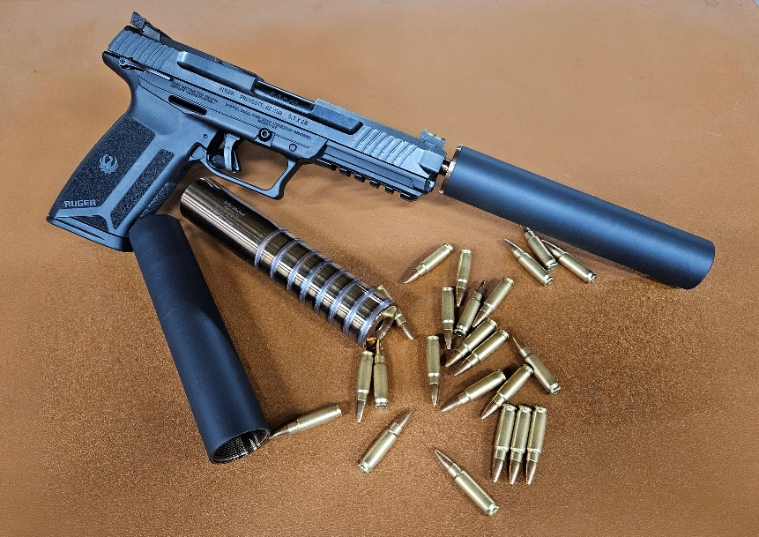
ABOUT THE CARACAL SUPPRESSOR  The Caracal is a fully welded tubeless 5.7mm caliber suppressors meant for use on semi-automatic handguns, carbines and PDW submachine guns. Available in both 17-4 H900 stainless steel and 6Al-4V titanium, it is 1.125-28 Alpha threaded for direct thread mounts or other 1.125-28 Alpha pattern adapters.  USING THE CARACAL SUPPRESSOR  The Caracal sports a .31” bore diameter and is rated for 5.7x28mm, .22 Hornet, .22 WMR, .22 TCM, .17 HMR, .17 WSM, .17 Hornet, .218 Bee, .25-20 Winchester, .256 Winchester magnum or any other cartridge .25 caliber or smaller burning 15 or fewer grain powder charges. Caracal is full auto rated, but suppressor temperature should be kept under 800°F for titanium versions and 1,000°F for 17-4 stainless steel versions. The Caracal is NOT approved for use with high velocity intermediate, full power or magnum centerfire rifle cartridges, and attempting to suppress a rifle with the Caracal could result in damage to the suppressor and the host firearm, and injury to the shooter or bystanders. .22 Short, Long and Long Rifle and cast bullet loads should not be used with Caracal due to leading of the fully welded non-serviceable suppressor.  Caracal can accept our Alpha booster assembly to be used on short recoil operated handguns. 5.7x28mm pistols typically do not need a booster, but .22 TCM pistols are often Browning type short recoil operated systems that do require a booster with mass exceeding ~4.5 ounces. We doalso manufacture ultralight aluminum direct thread mounts that may keep Caracal’s weight low enough to allow “boosterless” use on your .22 TCM handgun.  . | SERVICING THE CARACAL  The Caracal’s fully welded “tubeless” construction renders it non-serviceable, but it may be cleaned with any techniques and chemicals that are safe for stainless steel or titanium. If you choose to use any kind of vibratory tumbler, though, you must ensure that the media, especially stainless steel pin media, has been removed before using the suppressor again. Ultrasonic cleaning is a safer bet. The Norrell’s Moly Resin finish will hold up to any chemicals or cleaning solutions that won’t also attack the stainless steel or titanium.

