CANINE  WARRANTY  ALL ECCO MACHINE SOUND SUPPRESSORS (SILENCERS) CARRY A LIMITED LIFETIME WARRANTY AGAINST DEFECTS IN MATERIAL OR WORKMANSHIP, OR FAILURES THAT OCCUR DURING NORMAL, APPROVED USE OF THE SUPPRESSOR. ABUSE IS NOT COVERED, INCLUDING BUT NOT LIMITED TO USE OF ECCO MACHINE SUPPRESSORS THAT ARE NOT FULL AUTO RATED ON MACHINE GUNS, USE OF ECCO MACHINE SUPPRESSORS WITH CARTRIDGES OR BARREL LENGTHS NOT APPROVED FOR THE MODEL, BAFFLE STRIKES RESULTING FROM IMPROPER MOUNTING OR FAILURE TO SECURE THE SUPPRESSOR, OR DAMAGE CAUSED BY THE END USER ATTEMPTING TO SERVICE THE SUPPRESSOR. DETERMINATIONS ARE AT THE SOLE DISCRETION OF ECCO MACHINE. ECCO MACHINE ASSUMES NO RESPONSIBILITY OR LIABILITY FOR ANY DAMAGE TO WEAPONS OR INJURY TO PERSONS RESULTING FROM ANY COMBINATION OF IMPROPER USE OF SUPPRESSORS AND FAILURE TO OBSERVE PROPER FIREARM SAFETY, INCLUDING PROTECTIVE EQUIPMENT.  FOR QUESTIONS, SERVICE OR REPAIR, CONTACT:  ECCO MACHINE  37245 QUAIL DR.  ELIZABETH, CO 80107  303-646-5202  info@eccomachine.net | CANINE  9mm CALIBER PISTOL SUPPRESSOR  BY  ECCO MACHINE  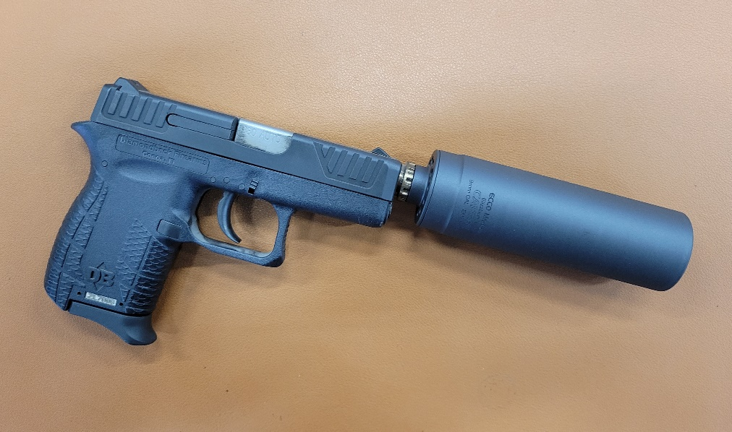
ABOUT THE CANINE PISTOL SUPPRESSOR  The Canine is a 9mm caliber suppressor meant for use on semi-automatic handguns and pistol caliber carbines. The light 3 ounce weight allows it’s use on short recoil operated handguns without the need for a recoil booster.  The Canine is a fully welded tubeless suppressor made of Gr. 5 titanium with a a 7075-T651 aluminum direct thread mount, and is rated for all 9mm caliber & smaller service type handgun cartridges, including .25 ACP, .32 ACP, .380 ACP, 9x19mm and 9x21mm, as well as .357 magnum, subsonic .350 legend and subsonic 9x39mm in rifles with 16” or longer barrels. Canine is NOT approved for use with other centerfire rifle cartridges, and attempting to suppress centerfire rifles with the Canine could result in damage to the suppressor, damage to the host firearm, and injury to the shooter or bystanders. .17 HMR and .22 WMR can be fired through the Canine, but the use of .22 Short, Long or Long Rifle is not recommended due to lead build up.  The Canine is designed for continuous use, but the temperature of the suppressor should not be allowed to exceed 800° F ( 410° C). Temperatures exceeding 800° F may embrittle the titanium, which can result in destruction of the suppressor, damage to the host firearm and injury to the shooter or bystanders. Evidence of overheating voids the warranty on the suppressor.  USING THE CANINE  The Canine is designed to be used “wet” with ablatives such as water, wire pulling gel or white grease. While it will suppress dry, performance without ablatives is commensurate with a very small can.  To apply ablatives, apply a small amount of ablative to the tips of the baffle cones on either side of the double clips with the included syringe, taking care to not obstruct the bores.  Recommended ablatives such as wire pulling gel or white lithium grease do carry inhalation risks, especially indoors. Please refer to MSDS sheets for any health risks associated with the use of any ablative materials. | SERVICING THE CANINE  The Canine is not a user-serviceable suppressor, but cleaning can be done chemically. There is no good metric for cleaning regimen, as the need varies greatly depending on the type of bullet and powder used, but ECCO Machine recommends cleaning the suppressor after the first 100 rounds and evaluating the need for shorter or longer intervals based on the amount of carbon deposits and other debris found.  While titanium is impervious to virtually all common cleaning chemicals, aluminum is much more reactive and can be damaged. There are aluminum safe chemicals which may preclude the need for mount removal, just be sure to verify that before using them.If the chemicals/methods you intend to use are not listed as aluminum safe, remove the mount prior to chemical or ultrasonic cleaning of Canine.  The thread adapter in the Canine has 1.125-28 male threads and is designed to be removed & installed with the included tool, or any adjustable pin wrench with 5/32 or 4mm pins. It should not require more torque than you can apply while holding the suppressor body in your other hand. Canine includes one adapter in the thread pitch specified at time of ordering; additional adapters are available from ECCO Machine. Canine will also accept any 1.125-28 Alpha threaded mount or adapter which is short enough to fit in the very small blast chamber, such as Griffin Cam Lok or EZ Lok. However, the added weight of mounts other than the aluminum ones we manufacture for Canine and TLX may increase the weight of the suppressor to the point that a short recoil handgun is unable to cycle properly.

