CHEETAH  WARRANTY  ALL ECCO MACHINE SOUND SUPPRESSORS (SILENCERS) CARRY A LIMITED LIFETIME WARRANTY AGAINST DEFECTS IN MATERIAL OR WORKMANSHIP, OR FAILURES THAT OCCUR DURING NORMAL, APPROVED USE OF THE SUPPRESSOR. ABUSE IS NOT COVERED, INCLUDING BUT NOT LIMITED TO USE OF ECCO MACHINE SUPPRESSORS THAT ARE NOT FULL AUTO RATED ON MACHINE GUNS, USE OF ECCO MACHINE SUPPRESSORS WITH CARTRIDGES OR BARREL LENGTHS NOT APPROVED FOR THE MODEL, BAFFLE STRIKES RESULTING FROM IMPROPER MOUNTING OR FAILURE TO SECURE THE SUPPRESSOR, OR DAMAGE CAUSED BY THE END USER ATTEMPTING TO SERVICE THE SUPPRESSOR. DETERMINATIONS ARE AT THE SOLE DISCRETION OF ECCO MACHINE. ECCO MACHINE ASSUMES NO RESPONSIBILITY OR LIABILITY FOR ANY DAMAGE TO WEAPONS OR INJURY TO PERSONS RESULTING FROM ANY COMBINATION OF IMPROPER USE OF SUPPRESSORS AND FAILURE TO OBSERVE PROPER FIREARM SAFETY, INCLUDING PROTECTIVE EQUIPMENT.  FOR QUESTIONS, SERVICE OR REPAIR, CONTACT:  ECCO MACHINE  37245 QUAIL DR.  ELIZABETH, CO 80107  303-646-5202  Info@ECCOMachine.net | CHEETAH  .32 CALIBER PISTOL SUPPRESSOR  BY  ECCO MACHINE  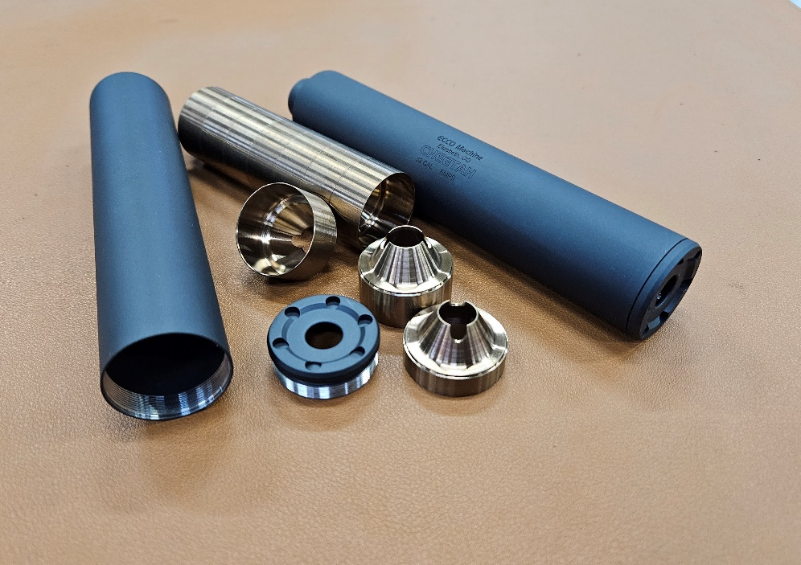
ABOUT THE CHEETAH PISTOL SUPPRESSOR  The Cheetah is a .32 Caliber (7.65mm) suppressor made of titanium and 17-4 H900 stainless steel, meant for use on fixed barrel semi-automatic and manually operated firearms. It has ½-28 threaded mount  The Cheetah is rated for all .32 caliber & smaller service handgun cartridges, including 5.7x28mm, .22 Hornet, .25-20 Winchester, .25 ACP, SUBSONIC .300 Blackout, .32 ACP, .32 H&R Magnum, 7.62x38Rmm Nagant, .32-20 Winchester, or any other .32 Caliber or smaller cartridge with operating pressure and powder charges not exceeding those of the 5.7x28mm or .32 H&R Magnum. It may be used on .327 Federal Magnum rifles or with high velocity .25-20 and .32-20 loads with 16” or longer barrels. While the suppressor has been tested with more powerful rounds, they will shorten the life of it drastically, as the Cheetah was built to be ultra light weight with the use of a thin grade 9 titanium housing. Cheetah is full auto rated, but temperature should be kept under 800°F to prevent embrittling of the titanium housing. The Cheetah is absolutely NOT approved for use with centerfire rifle cartridges, and attempting to suppress a rifle with the Cheetah could result in damage to the suppressor and the host firearm, and injury to the shooter or bystanders. .22 Short, Long and Long Rifle can certainly be fired through the Cheetah, but will necessitate more frequent cleaning, as will the use of any cast lead bullets in other cartridges.  The Cheetah is designed for continuous use, but the temperature of the suppressor should not be allowed to exceed 800°F. Temperatures exceeding 800° F weaken the Titanium housing, which can result in destruction of the suppressor, damage to the host firearm and injury to the shooter or bystanders. Evidence of overheating voids the warranty on the suppressor. | SERVICING THE CHEETAH  The Cheetah is a user-serviceable suppressor in regards to normal maintenance (cleaning). There is no good metric for cleaning regimen, as the need varies greatly depending on the type of bullet and powder used, but ECCO Machine recommends cleaning the suppressor after the first 500 rounds and evaluating the need for shorter or longer intervals based on the amount of carbon deposits and other debris found. Ultimately, you can clean off any buildup that occurs, but don’t want the baffles becoming too difficult to drive out of the housing.  If you feel the effort to drive the baffles out is excessive, soak the suppressor overnight in a gun cleaning solvent to loosen the deposits that are causing the baffles to stick in the housing and attempt to remove them the following day. If you are unable to remove them, you may return the suppressor to ECCO Machine for service.  The titanium and stainless steel parts of the Cheetah may be cleaned with aggressive chemicals and ultrasonic cleaners, but always refer to the MSDS of a chemical before use both to ensure that it won’t damage the items you want to clean, and that you have the proper protective equipment and a suitable environment for use.  The baffles in the Cheetah are not orientation specific, and except for the first and last, position in the stack does not matter. To reassemble, stack the baffles face down on a level surface, then slide the housing onto the baffle stack. Now the end cap is installed; make sure the threads are clean, and it is recommended that you apply a very small amount of silicone, molybdenum or other high temperature grease to the threads and rear edge of the cap. Take care in starting the threads of the cap, as they are a very fine 36 pitch. If the cap will not screw down all the way, do not force it with the wrench, as you likely have debric cause between parts and could cause damage it by torqueing the cap down. The baffle stack is a precise fit, and the wrench is needed to tighten the cap fully, but you should only need the wrench for the about the last 1/8 to 1/4 revolution or so.

