FURTIVUS  WARRANTY  ALL ECCO MACHINE SOUND SUPPRESSORS (SILENCERS) CARRY A LIMITED LIFETIME WARRANTY AGAINST DEFECTS IN MATERIAL OR WORKMANSHIP, OR FAILURES THAT OCCUR DURING NORMAL, APPROVED USE OF THE SUPPRESSOR. ABUSE IS NOT COVERED, INCLUDING BUT NOT LIMITED TO USE OF ECCO MACHINE SUPPRESSORS THAT ARE NOT FULL AUTO RATED ON MACHINE GUNS, USE OF ECCO MACHINE SUPPRESSORS WITH CARTRIDGES OR BARREL LENGTHS NOT APPROVED FOR THE MODEL, BAFFLE STRIKES RESULTING FROM IMPROPER MOUNTING OR FAILURE TO SECURE THE SUPPRESSOR, OR DAMAGE CAUSED BY THE END USER ATTEMPTING TO SERVICE THE SUPPRESSOR. DETERMINATIONS ARE AT THE SOLE DISCRETION OF ECCO MACHINE. ECCO MACHINE ASSUMES NO RESPONSIBILITY OR LIABILITY FOR ANY DAMAGE TO WEAPONS OR INJURY TO PERSONS RESULTING FROM ANY COMBINATION OF IMPROPER USE OF SUPPRESSORS AND FAILURE TO OBSERVE PROPER FIREARM SAFETY, INCLUDING PROTECTIVE EQUIPMENT.  FOR QUESTIONS, SERVICE OR REPAIR, CONTACT:  ECCO MACHINE  37245 QUAIL DR.  ELIZABETH, CO 80107  303-646-5202  Info@ECCOMachine.net | FURTIVUS  CENTERFIRE RIFLE SUPPRESSOR  BY  ECCO MACHINE  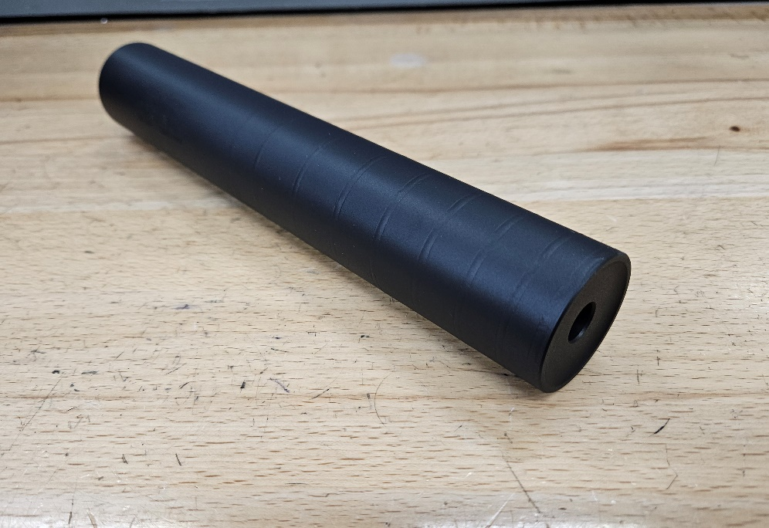
ABOUT THE FURTIVUS RIFLE SUPPRESSOR  The Futivus is a medium duty suppressor meant for use on full power and magnum rifles It is made entirely from heat treated 17-4 PH stainless steel.  The Furtivus is rated for all rifle cartridges using up to 80 grain powder charges. It is rated for full auto use, but temperature should be monitored and kept under 900°F. If the temperature of the suppressor exceeds 900°F for a prolonged period, the temper of the stainless steel may be affected. Evidence of overheating voids the suppressor warranty.  USING THE FURTIVUS  The Furtivus is equipped with 1.125-28 Alpha threads. It will accept any industry standard 1.125-28 Alpha pattern mount or adapter, which may be referred to as Alpha or simply the nominal 1.125-28 thread size.  Under no circumstances are crush washers permissible for mounting suppressors, or for installation of a suppressor muzzle device. Direct contact with the thread tenon shoulder or precision shims/washers is mandatory for proper axial alignment.  If you are using a muzzle device mounting system, ensure that your muzzle device is compatible with your host bore size. Firing an oversize bullet through a muzzle device is likely to damage the muzzle device and the suppressor. | SERVICING THE FURTIVUS  The Furtivus is not a user-serviceable suppressor. It is fully fusion TIG welded tubeless type suppressor constructed entirely of 17-4 PH stainless steel in H900 temper, so manual cleaning of individual baffles is not possible. You can use any prescribed method for cleaning sealed suppressors, such as solvent baths or ultrasonic cleaning.  If you are using a muzzle device mounting system, the mating surface on both the muzzle device and the suppressor should be wiped clean of debris and carbon and inspected before installation to ensure proper alignment, proper retention, and to prevent surfaces being damaged by debris.  As with any suppressor, be sure to sufficiently torque the suppressor so that it does not come loose during firing, causing baffle strikes  Use of .22 short, long or long rifle is not recommended in FURTIVUS, nor is the use of any cast lead bullets.  SUPPRESSOR RATINGS  Limited full auto (not continuous full auto fire/repeated back-to-back magazine “dumps”).  -cartridges burning over 80 grains are not approved  -60-80 gr cartridges 20” & longer barrel  -45-60 gr cartridge 16” & Longer barrel  -25-45 gr. Cartridges 12” & longer barrel  -Under 25 gr cartridge no barrel restriction  *Muzzle brake muzzle device required for barrels shorter than 12″

