OCELOT SERIES  WARRANTY  ALL ECCO MACHINE SOUND SUPPRESSORS (SILENCERS) CARRY A LIMITED LIFETIME WARRANTY AGAINST DEFECTS IN MATERIAL OR WORKMANSHIP, OR FAILURES THAT OCCUR DURING NORMAL, APPROVED USE OF THE SUPPRESSOR. ABUSE IS NOT COVERED, INCLUDING BUT NOT LIMITED TO USE OF ECCO MACHINE SUPPRESSORS THAT ARE NOT FULL AUTO RATED ON MACHINE GUNS, USE OF ECCO MACHINE SUPPRESSORS WITH CARTRIDGES OR BARREL LENGTHS NOT APPROVED FOR THE MODEL, BAFFLE STRIKES RESULTING FROM IMPROPER MOUNTING OR FAILURE TO SECURE THE SUPPRESSOR, OR DAMAGE CAUSED BY THE END USER ATTEMPTING TO SERVICE THE SUPPRESSOR. DETERMINATIONS ARE AT THE SOLE DISCRETION OF ECCO MACHINE. ECCO MACHINE ASSUMES NO RESPONSIBILITY OR LIABILITY FOR ANY DAMAGE TO WEAPONS OR INJURY TO PERSONS RESULTING FROM ANY COMBINATION OF IMPROPER USE OF SUPPRESSORS AND FAILURE TO OBSERVE PROPER FIREARM SAFETY, INCLUDING PROTECTIVE EQUIPMENT.  FOR QUESTIONS, SERVICE OR REPAIR, CONTACT:  ECCO MACHINE  37245 QUAIL DR.  ELIZABETH, CO 80107  303-646-5202  Info@ECCOMachine.net | OCELOT SERIES  .22 CALIBER RIMFIRE SUPPRESSORS  BY  ECCO MACHINE  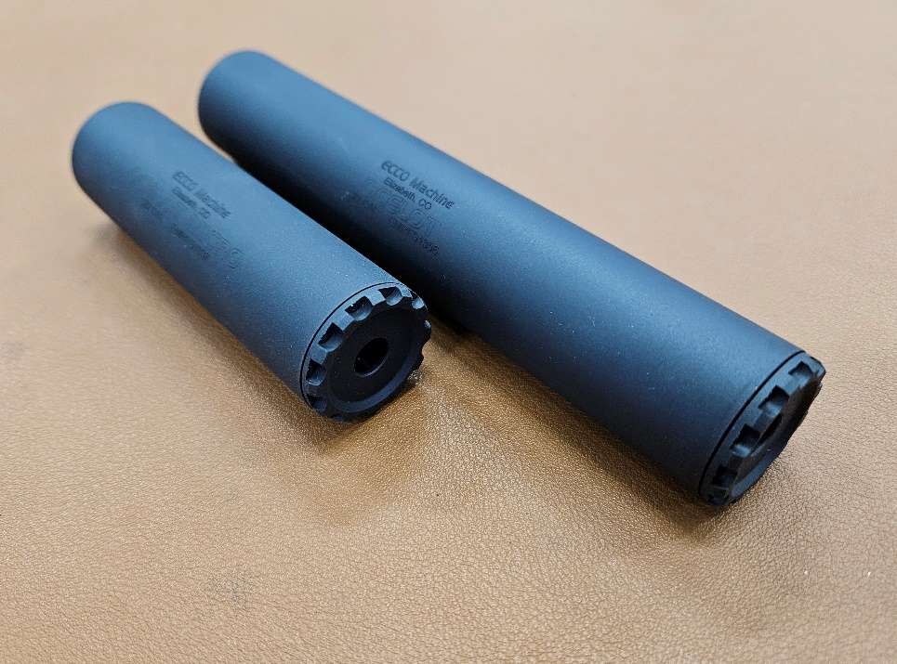
ABOUT THE OCELOT SERIES SUPPRESSORS  The Ocelot series are .22 caliber suppressors meant for use on rimfire firearms. Ocelot suppressors are made of titanium with 17-4 H900 stainless steel indexing baffles.  There are 2 Ocelot models:  -Ocelot, 5.5” long, 4.1 ounces, 11 baffles. Rated up to 5.7x28mm FN or .22 Hornet, full auto rated so long as suppressor temperature does not exceed 800°F. May be run dry or wet (max 2cc ablative)  -Ocelot Micro, 3.5” long, 3 ounces, 6 baffles. Rated up to 5.7x28mm FN or .22 Hornet, full auto rated so long as suppressor temperature does not exceed 800°F. May be run dry or wet (max 1.2cc ablative)  Do not attempt to use Ocelot suppressors with cartridges they are not rated for. There is very little blast chamber in rimfire suppressors, so using them with cartridges that have higher exit pressures and greater gas volume may result in destruction of the suppressor, damage to the host firearm and injury to the shooter or bystanders.  SERVICING THE OCELOT  The Ocelot series suppressors are user-serviceable suppressor in regards to normal maintenance (cleaning). There is no good metric for cleaning regimen, as the need varies greatly depending on the type of bullet and powder used, but ECCO Machine recommends cleaning the suppressor after the first 500 rounds and evaluating the need for shorter or longer intervals based on the amount of carbon deposits and other debris found. Ultimately, you can clean off any buildup that occurs, but don’t want the baffles becoming too difficult to drive out of the housing.  The included wrench is used to remove the front cap, and then the included acetyl rod is inserted from the rear and pushed or gently tapped to drive the stack | of baffles out the front of the housing. Should the acetyl rod be lost, a 3/8” polymer or wooden dowel is an acceptable replacement. Care must be taken to ensure the dowels make contact with the entire circumference of the rear baffle cone tip. Metallic rods or undersize rods could damage the baffle cone.  If you feel the effort to drive the baffles out is excessive, soak the suppressor overnight in a gun cleaning solvent or penetrating oil to loosen the deposits that are causing the baffles to stick in the housing and attempt to remove them the following day. If you are unable to remove them, you may return the suppressor to ECCO Machine for service.  The titanium and stainless steel parts of the Ocelot series may be cleaned with aggressive chemicals and ultrasonic cleaners, but always refer to the MSDS of a chemical before use both to ensure that it won’t damage the items you want to clean, and that you have the proper protective equipment and a suitable environment for use.  The baffles in the Ocelot series are not position specific except for first and last, and the orientation of the clip does not matter, though we have found aligned to produce best results. It is easiest to stack the baffles face down and then slide the tube over them. Make sure all indexing tabs are seated into the cuts on the rear of the next baffle. Now the end cap is installed; make sure the threads are clean, and it is recommended that you apply a very small amount of silicone, molybdenum or other high temperature grease to the threads and rear edge of the cap. Take care in starting the threads of the cap, as they are a very fine 36 pitch. If the cap will not screw down all the way, do not force it with the wrench, as you likely have a misaligned baffle indexing notch or debris between baffles, and may cause damage by torqueing the cap down. The baffle stack is a precise fit, and the wrench is needed to tighten the cap fully, but you should only need the wrench for the about the last 1/8 to 1/4 revolution or so.

