PHOENIX XLV  WARRANTY  ALL ECCO MACHINE SOUND SUPPRESSORS (SILENCERS) CARRY A LIMITED LIFETIME WARRANTY AGAINST DEFECTS IN MATERIAL OR WORKMANSHIP, OR FAILURES THAT OCCUR DURING NORMAL, APPROVED USE OF THE SUPPRESSOR. ABUSE IS NOT COVERED, INCLUDING BUT NOT LIMITED TO USE OF ECCO MACHINE SUPPRESSORS THAT ARE NOT FULL AUTO RATED ON MACHINE GUNS, USE OF ECCO MACHINE SUPPRESSORS WITH CARTRIDGES OR BARREL LENGTHS NOT APPROVED FOR THE MODEL, BAFFLE STRIKES RESULTING FROM IMPROPER MOUNTING OR FAILURE TO SECURE THE SUPPRESSOR, OR DAMAGE CAUSED BY THE END USER ATTEMPTING TO SERVICE THE SUPPRESSOR. DETERMINATIONS ARE AT THE SOLE DISCRETION OF ECCO MACHINE. ECCO MACHINE ASSUMES NO RESPONSIBILITY OR LIABILITY FOR ANY DAMAGE TO WEAPONS OR INJURY TO PERSONS RESULTING FROM ANY COMBINATION OF IMPROPER USE OF SUPPRESSORS AND FAILURE TO OBSERVE PROPER FIREARM SAFETY, INCLUDING PROTECTIVE EQUIPMENT.  FOR QUESTIONS, SERVICE OR REPAIR, CONTACT:  ECCO MACHINE  37245 QUAIL DR.  ELIZABETH, CO 80107  303-646-5202  Info@ECCOMachine.net | PHOENIX IX  9mm CALIBER PISTOL SUPPRESOR  BY  ECCO MACHINE  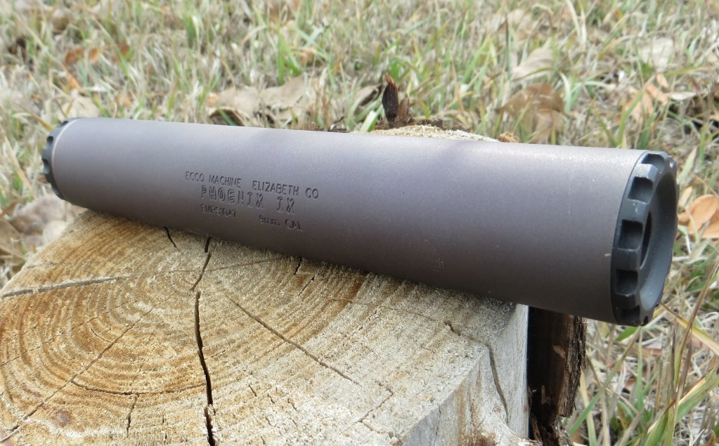
ABOUT THE PHOENIX IX PISTOL SUPPRESSOR  The Phoenix IX is a 9mm caliber suppressors meant for use on semi-automatic short recoil operated handguns and pistol caliber carbines. It has an integral recoil booster assembly to facilitate proper cycling of such firearms, and uses interchangeable “pistons” with threads to match the host firearm. It may be used on fixed barrel firearms, but should have the piston spring removed and replaced by a fixed barrel spacer, or the rear cap replaced with a direct thread mount. Removal and installation of the rear cap or direct thread mount is done either by hand, or with the end cap wrench if necessary.  The Phoenix IX is constructed of Gr. 9 CWSR titanium, Gr. 5 titanium and 17-4 H900 stainless steel, and is rated for all 9mm caliber & smaller service type handgun cartridges, including .25 ACP, SUBSONIC .300 Blackout, .32 ACP, .380 ACP, 9x19mm, 9x21mm, .357 Sig, .38 Special, .38 Super, .357 Magnum any others with operating pressure and powder charges not exceeding those of the.357 Magnum. While the suppressor has been tested with more powerful rounds, it was not designed for them with the ultra light weight thin walled grade titanium housing and fine 36 pitch threads. Phoenix IX is full auto rated with 9mm Luger and smaller cartridges. The Phoenix is absolutely NOT approved for use with centerfire rifle cartridges, and attempting to suppress a rifle with the Phoenix IX could result in damage to the suppressor and the host firearm, and injury to the shooter or bystanders. .22 Short, Long and Long Rifle can certainly be fired through the Phoenix XLV, but will necessitate more frequent cleaning, as will the use of any cast lead bullets in other cartridges.  The Phoenix IX is designed for continuous use, but the temperature of the suppressor should not be allowed to exceed 800° F ( 425° C). Temperatures in excess of 800° F. Temperatures exceeding 800° F weaken the Titanium housing, which can result in destruction of the suppressor, damage to the host firearm and injury to the shooter or bystanders. Evidence of overheating voids the warranty on the suppressor. | SERVICING THE PHOENIX IX  The Phoenix is a user-serviceable suppressor in regards to normal maintenance (cleaning). There is no good metric for cleaning regimen, as the need varies greatly depending on the type of bullet and powder used, but ECCO Machine recommends cleaning the suppressor after the first 500 rounds and evaluating the need for shorter or longer intervals based on the amount of carbon deposits and other debris found. Ultimately, you can clean off any buildup that occurs, but don’t want the baffles becoming too difficult to drive out of the housing.  The included wrench is used to remove the front cap, and the baffles may be pushed out with a ~5/8” rod or dowel. If the baffles are difficult to push out, do DO NOT use metallic rods with hammers or other impact devices, as this may damage the baffle face. In this instance, first use a solvent to soften carbon deposits, and then a polymer rod is recommended with gentle tapping. Be sure to use dowels that will make contact with the entire circumference of the rear baffle cone.  If you feel the effort to drive the baffles out is still excessive after soaking the suppressor in cleaning solvents to loosen the deposits that are causing the baffles to stick in the housing, you may return the suppressor to ECCO Machine for service.  The baffles in the Phoenix IX have “clips” to disrupt laminar flow, and these clips need to be aligned. There are indexing features on each baffle to ensure this alighment. If the clips are misaligned or the end cap has an excessive gap, it is likely that the indexing tabs are not aligned, so the baffle stack will need to be removed, aligned and reinstalled. It is helpful to removed the booster cap, spring and piston and apply pressure from the rear of the stack with a rod while sliding the tube over the baffles to keep the tabs from unseating. Take care in starting the threads of the cap, as they are a very fine 36 pitch. The baffle stack is a precise fit, and the wrench is needed to tighten the cap fully, but you should only need the wrench for the about the last 1/8 to 1/4 revolution or so.

