PHOENIX TL  WARRANTY  ALL ECCO MACHINE SOUND SUPPRESSORS (SILENCERS) CARRY A LIMITED LIFETIME WARRANTY AGAINST DEFECTS IN MATERIAL OR WORKMANSHIP FOR FAILURES THAT OCCUR DURING NORMAL, APPROVED USE OF THE SUPPRESSOR. ABUSE IS NOT COVERED, INCLUDING BUT NOT LIMITED TO USE OF ECCO MACHINE SUPPRESSORS THAT ARE NOT FULL AUTO RATED ON MACHINE GUNS, USE OF ECCO MACHINE SUPPRESSORS WITH CARTRIDGES OR BARREL LENGTHS NOT APPROVED FOR THE MODEL, BAFFLE STRIKES RESULTING FROM IMPROPER MOUNTING OR FAILURE TO SECURE THE SUPPRESSOR, OR DAMAGE CAUSED BY THE END USER ATTEMPTING TO SERVICE THE SUPPRESSOR. DETERMINATIONS ARE AT THE SOLE DISCRETION OF ECCO MACHINE. USE OF FIREARMS HAS INHERENT RISKS AND WE HAVE NO CONTROL OVER THE OTHER PARTS, ASSEMBLIES AND CONSUMABLES THAT MAY BE USED IN CONJUNCTION WITH OUR PRODUCTS; AS SUCH, ECCO MACHINE BEARS NO RESPONSIBILITY FOR ANY INJURY OR LOSS.  FOR QUESTIONS, SERVICE OR REPAIR, CONTACT:  ECCO MACHINE  37245 QUAIL DR.  ELIZABETH, CO 80107  303-646-5202  Info@ECCOMachine.net | PHOENIX TL  9mm CALIBER PISTOL SUPPRESSOR  BY  ECCO MACHINE  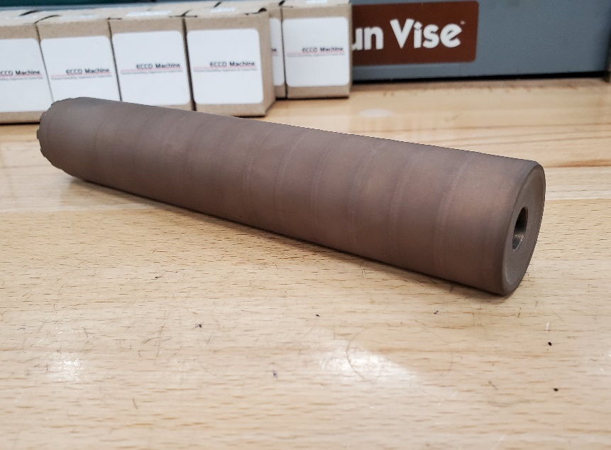
ABOUT THE PHOENIX TL PISTOL SUPPRESSOR  The Phoenix TL is a 9mm caliber suppressors meant for use on semi-automatic short recoil operated handguns and pistol caliber carbines. It may use an external booster, direct thread mount or other 1.125-28 Alpha pattern adapters. The separately available recoil booster assembly is to facilitate proper cycling of recoil operated handguns, and uses interchangeable “pistons” with threads to match the host firearm. For use on fixed barrel firearms, either install a fixed barrel type mount or replace the piston spring with a fixed barrel spacer, Removal and installation of the rear cap or direct thread mounts we manufacture is done either with a 1-1/16” or 27mm 12-point wrench or socket, or with an available Alpha mount wrench. Other manufacturer’s mounts and adapters may require different tools.  USING THE PHOENIX TL PISTOL SUPPRESSOR  The Phoenix TL is constructed of entirely 17-4 H900 stainless steel, and is rated for all 9mm caliber & smaller service type handgun cartridges, including .25 ACP, SUBSONIC .300 Blackout, .32 ACP, .380 ACP, 9x19mm, 9x21mm, .357 Sig, .38 Special, .38 Super, SUBSONIC .350 Legend, SUBSONIC 9x39mm, .357 Magnum, and any other cartridges with operating pressure and powder charges not exceeding those of the.357 Magnum. Phoenix TL is full auto rated with 9mm Luger and smaller cartridges. The Phoenix TL is NOT approved for use with high velocity centerfire rifle cartridges, and attempting to suppress a rifle with the Phoenix TL could result in damage to the suppressor and the host firearm, and injury to the shooter or bystanders. .22 Short, Long and Long Rifle and cast bullet loads should not be used with Phoenix TL due to leading of the fully welded non-serviceable suppressor. Rimfires which use jacketed bullets such as .22 WMR and .17 HMR are fine.  . | SERVICING THE PHOENIX IX  The Phoenix TL is a fully welded “tubeless” suppressor and not serviceable, but it may be cleaned with any techniques and chemicals that are safe for stainless steel. If you choose to use any kind of vibratory tubler, though, you must ensure that the media, especially stainless steel pin media, has been removed before using the suppressor again. Ultrasonic cleaning is a safer bet. The Norrell’s Moly Resin finish will hold up to any chemicals or cleaning solutions that won’t also attack the stainless steel.

