PHOENIX XLV  WARRANTY  ALL ECCO MACHINE SOUND SUPPRESSORS (SILENCERS) CARRY A LIMITED LIFETIME WARRANTY AGAINST DEFECTS IN MATERIAL OR WORKMANSHIP FOR FAILURES THAT OCCUR DURING NORMAL, APPROVED USE OF THE SUPPRESSOR. ABUSE IS NOT COVERED, INCLUDING BUT NOT LIMITED TO USE OF ECCO MACHINE SUPPRESSORS THAT ARE NOT FULL AUTO RATED ON MACHINE GUNS, USE OF ECCO MACHINE SUPPRESSORS WITH CARTRIDGES OR BARREL LENGTHS NOT APPROVED FOR THE MODEL, BAFFLE STRIKES RESULTING FROM IMPROPER MOUNTING OR FAILURE TO SECURE THE SUPPRESSOR, OR DAMAGE CAUSED BY THE END USER ATTEMPTING TO SERVICE THE SUPPRESSOR. DETERMINATIONS ARE AT THE SOLE DISCRETION OF ECCO MACHINE. USE OF FIREARMS HAS INHERENT RISKS AND WE HAVE NO CONTROL OVER THE OTHER PARTS, ASSEMBLIES AND CONSUMABLES THAT MAY BE USED IN CONJUNCTION WITH OUR PRODUCTS; AS SUCH, ECCO MACHINE BEARS NO RESPONSIBILITY FOR ANY INJURY OR LOSS.  FOR QUESTIONS, SERVICE OR REPAIR, CONTACT:  ECCO MACHINE  37245 QUAIL DR.  ELIZABETH, CO 80107  303-646-5202  Info@ECCOMachine.net | PHOENIX XLV  .45 CALIBER PISTOL SUPPRESSOR  BY  ECCO MACHINE  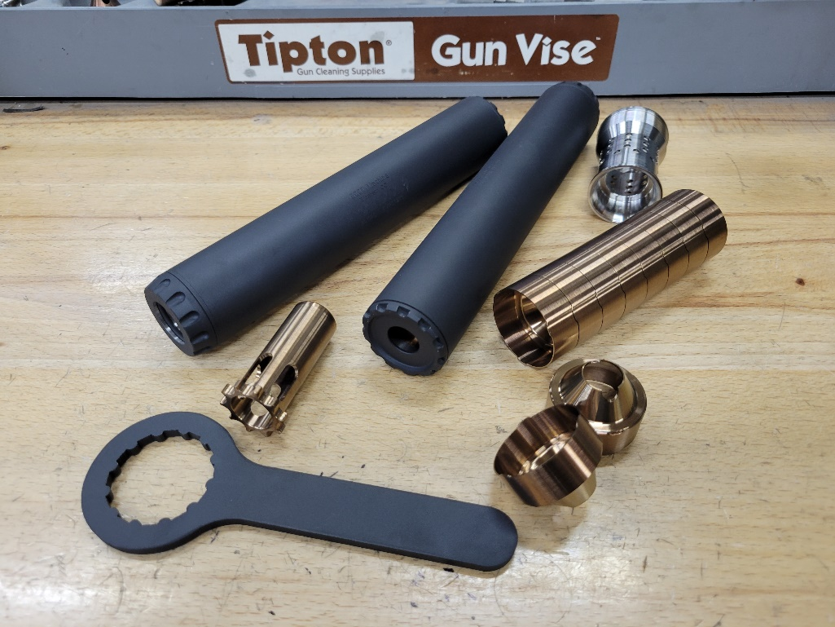
ABOUT THE PHOENIX XLV PISTOL SUPPRESSOR  The Phoenix XLV is a .45 caliber suppressor meant for use on semi-automatic short recoil operated handguns and carbines firing pistol caliber or low pressure cartridges. It has an integral recoil booster assembly to facilitate proper cycling of such firearms, and uses interchangeable BPISTIN pattern pistons with threads to match the host firearm. It may be used on fixed barrel firearms, but the piston & spring must be removed and the rear cap replaced with an available direct thread mount or taper/QD mount adapter. Removal and installation of the rear cap or direct thread mount is done either by hand, or with the end cap wrench if necessary.  Phoenix XLV has 1.125-28 Alpha pattern threads in the booster housing which will accept a wide variety of mounts and adapters, including direct thread mounts, taper or QD mount adapters and 3 lug adapters.  The Phoenix XLV is rated for all .45 caliber & smaller service type handgun cartridges with no barrel length restrictions for .25 ACP, SUBSONIC .300 Blackout, .32 ACP, .32 W.C.F., .380 ACP, 9x19mm, 9x21mm, .357 Sig, .38 Special, .38 Super, .357 Magnum, .40 S&W, 10mm Auto, .45 ACP, .45 Super. Minimum barrel length is 16” for Magnum handgun cartridges larger than .357 Magnum and low pressure rifle rounds such as .458 Socom or .45-70 Government. The suppressor is NOT rated for “hot” .45-70 loads intended for Ruger #1 & bolt action firearms. The Phoenix XLV is NOT rated for use with high velocity centerfire rifle cartridges, and attempting to suppress a high powered rifle with the Phoenix XLV could result in damage to the suppressor, damage to the host firearm and injury to the shooter or bystanders. .22 Short, Long and Long Rifle can certainly be fired through the Phoenix XLV, but may necessitate more frequent cleaning, as will the use of any cast lead bullets in other cartridges.  The Phoenix XLV is designed for continuous use and is “full auto rated” with service type pistol cartridges, but the temperature of the suppressor should not be allowed to exceed 800° F ( 260 ° C). Temperatures in excess of 800° F may embrittle the Titanium parts, which can result in destruction of the suppressor, damage to the host firearm and injury to the shooter or bystanders. Evidence of overheating voids the warranty on the suppressor. | SERVICING THE PHOENIX XLV  The Phoenix XLV is a user-serviceable suppressor in regards to normal maintenance (cleaning). There is no good metric for cleaning regimen, as the need varies greatly depending on the type of bullet and powder used, but ECCO Machine recommends cleaning the suppressor after the first 500 rounds and evaluating the need for shorter or longer intervals based on the amount of carbon deposits and other debris found. Ultimately, you can clean off any buildup that occurs, but don’t want the baffles becoming too difficult to drive out of the housing.  The included wrench is used to remove the front cap, and then a rod or dowel of approximately 5/8-11/16” diameter may be used to push or gently tap the stack of 10 indexing baffles out the front of the housing. Undersized rods will not properly distribute the forces and could damage the baffle cones.  If you feel the effort to drive the baffles out is excessive, soak the suppressor overnight in a cleaning solvent to loosen the deposits that are causing the baffles to stick in the housing and attempt to remove them the following day. If you are unable to remove them, you may return the suppressor to ECCO Machine for service. DO NOT ultrasonic clean the Phoenix.  The baffles in the Phoenix XLV have “clips” to disrupt laminar flow, and these clips need to be aligned. Each baffle has indexing features for this purpose. The baffle stack sould be assembled face down on a solid surface and then the tube installed over the stack. Now the end cap is installed; make sure the threads are clean, and it is recommended that you apply a very small amount of silicone, molybdenum or other high temperature grease or anti-seize to the threads and rear edge of the cap. Take care in starting the threads of the cap, as they are a very fine 36 pitch. The baffle stack is a precise fit, and the wrench is needed to tighten the cap fully, but you should only need the wrench for the about the last 1/8 to 1/4 revolution or so.  As with any firearm suppressor, verifying alignment with the bore of the host firearm is the end user’s responsibility.

