SALAMANDER  WARRANTY  ALL ECCO MACHINE SOUND SUPPRESSORS (SILENCERS) CARRY A LIMITED LIFETIME WARRANTY AGAINST DEFECTS IN MATERIAL OR WORKMANSHIP, OR FAILURES THAT OCCUR DURING NORMAL, APPROVED USE OF THE SUPPRESSOR. ABUSE IS NOT COVERED, INCLUDING BUT NOT LIMITED TO USE OF ECCO MACHINE SUPPRESSORS THAT ARE NOT FULL AUTO RATED ON MACHINE GUNS, USE OF ECCO MACHINE SUPPRESSORS WITH CARTRIDGES OR BARREL LENGTHS NOT APPROVED FOR THE MODEL, BAFFLE STRIKES RESULTING FROM IMPROPER MOUNTING OR FAILURE TO SECURE THE SUPPRESSOR, OR DAMAGE CAUSED BY THE END USER ATTEMPTING TO SERVICE THE SUPPRESSOR. DETERMINATIONS ARE AT THE SOLE DISCRETION OF ECCO MACHINE. ECCO MACHINE ASSUMES NO RESPONSIBILITY OR LIABILITY FOR ANY DAMAGE TO WEAPONS OR INJURY TO PERSONS RESULTING FROM ANY COMBINATION OF IMPROPER USE OF SUPPRESSORS AND FAILURE TO OBSERVE PROPER FIREARM SAFETY, INCLUDING PROTECTIVE EQUIPMENT.  FOR QUESTIONS, SERVICE OR REPAIR, CONTACT:  ECCO MACHINE  37245 QUAIL DR.  ELIZABETH, CO 80107  303-646-5202  Info@ECCOMachine.net | SALAMANDER  .22 CALIBER RIMFIRE SUPPRESSOR  BY  ECCO MACHINE  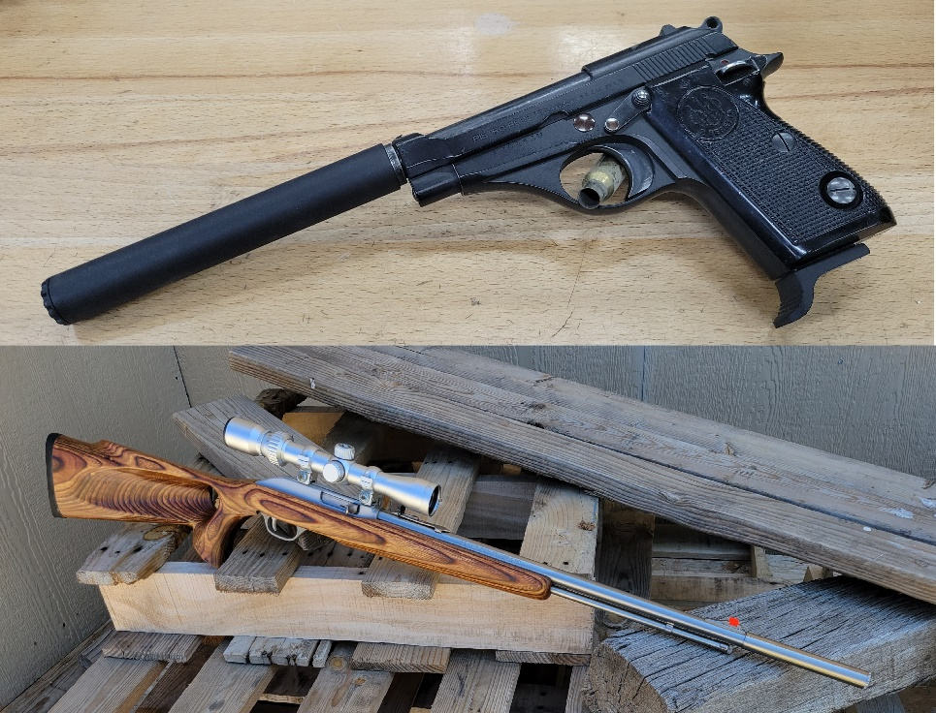
ABOUT THE SALAMANDER SUPPRESSOR  The Salamander is a .22 caliber suppressor meant for use on rimfire firearms.  It is our “slimline” rimfire suppressor meant to make reloading of tube fed rifles possible without removing the suppressor, and also to be less obtrusive to sights on smaller rimfire pistols where typical 1” rimfire suppressors would occlude  them.  Salamander is constructed entirely of titanium and stainless steel for durability and ease of cleaning. Aggressive chemical cleaners which are suitable for those materials may be used, and all the parts are safe for ultrasonic cleaners. Aggressive mechanical cleaning, such as wire wheels or abrasive blasting, is not recommended, and if you choose to use those methods, be aware that they do remove small amounts of material in addition to the deposits.  Salamander is rated for all .22 rimfire cartridges and the .17 HMR.  Do not attempt to use Salamander with cartridges it is not rated for. There is very little blast chamber in this tiny suppressor, using it with cartridges that have higher exit pressures and greater gas volume may result in destruction of the suppressor, damage to the host firearm and injury to the shooter or bystanders.  Specifications:  Length: 5”  Outside Diameter: .75"  Inside Diameter: .68”  Weight: 2.5 Ounces  Tube Material: Gr. 9 CWSR Titanium  Mount & Cap Material: Gr. 5 Titanium  Baffle Material: 17-4 H900 Stainless Steel | SERVICING THE SALAMANDER  The Salamander is user-serviceable suppressor in regards to normal maintenance (cleaning). There is no good metric for cleaning regimen, as the need varies greatly depending on the type of bullet and powder used, but ECCO Machine recommends cleaning the suppressor after the first 500 rounds and evaluating the need for shorter or longer intervals based on the amount of carbon deposits and other debris found. Ultimately, you can clean off any buildup that occurs, but don’t want the baffles becoming too difficult to drive out of the housing.  A 17mm or 11/16 12-point wrench or socket is used to remove the front cap, and then the included acetyl rod is inserted from the rear and pushed or gently tapped to drive the baffle stack out. Should the acetyl rod be lost, a ~3/8” polymer or wooden dowel is an acceptable replacement. DO NOT use metallic rods, and be sure to use dowels that will make contact with the entire circumference of the rear baffle cone. Metallic rods or undersize rods could damage the baffle cone.  If you feel the effort to drive the baffles out is excessive, soak the suppressor overnight in a gun cleaning solvent or penetrating oil to loosen the deposits that are causing the baffles to stick in the housing and attempt to remove them the following day. If you are unable to remove them, you may return the suppressor to ECCO Machine for service.  Take care in starting the threads of the cap on reassembly, as they are a very fine 36 pitch. If the cap will not screw down all the way, do not force it with the wrench, as you likely have debris between baffles, and may cause damage by torquing the cap down. The baffle stack is a precise fit, and the wrench is needed to tighten the small cap fully, but you should only need minimal torque to seat mating surface and prevent the cap from loosening.

