SUSURRUS CF  WARRANTY  ALL ECCO MACHINE SOUND SUPPRESSORS (SILENCERS) CARRY A LIMITED LIFETIME WARRANTY AGAINST DEFECTS IN MATERIAL OR WORKMANSHIP, OR FAILURES THAT OCCUR DURING NORMAL, APPROVED USE OF THE SUPPRESSOR. ABUSE IS NOT COVERED, INCLUDING BUT NOT LIMITED TO USE OF ECCO MACHINE SUPPRESSORS THAT ARE NOT FULL AUTO RATED ON MACHINE GUNS, USE OF ECCO MACHINE SUPPRESSORS WITH CARTRIDGES OR BARREL LENGTHS NOT APPROVED FOR THE MODEL, BAFFLE STRIKES RESULTING FROM IMPROPER MOUNTING OR FAILURE TO SECURE THE SUPPRESSOR, OR DAMAGE CAUSED BY THE END USER ATTEMPTING TO SERVICE THE SUPPRESSOR. DETERMINATIONS ARE AT THE SOLE DISCRETION OF ECCO MACHINE. ECCO MACHINE ASSUMES NO RESPONSIBILITY OR LIABILITY FOR ANY DAMAGE TO WEAPONS OR INJURY TO PERSONS RESULTING FROM ANY COMBINATION OF IMPROPER USE OF SUPPRESSORS AND FAILURE TO OBSERVE PROPER FIREARM SAFETY, INCLUDING PROTECTIVE EQUIPMENT.  FOR QUESTIONS, SERVICE OR REPAIR, CONTACT:  ECCO MACHINE  37245 QUAIL DR.  ELIZABETH, CO 80107  303-646-5202  Info@ECCOMachine.net | SUSURRUS CF  INTEGRAL RIFLE SUPPRESSOR  BY  ECCO MACHINE  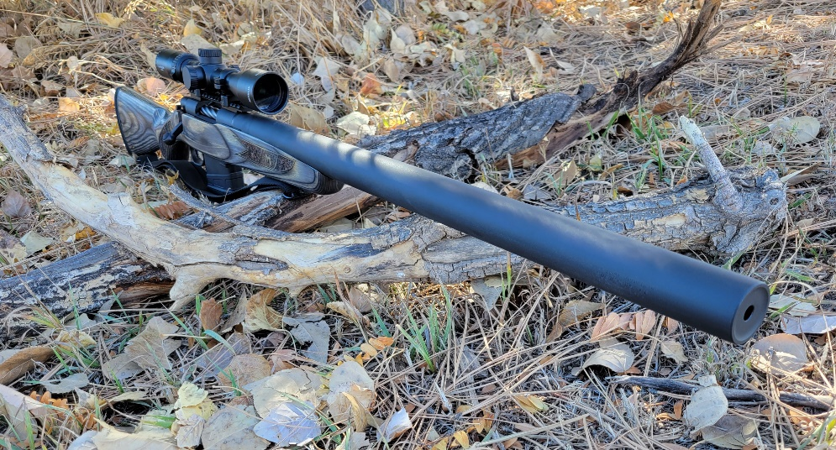
ABOUT THE SUSURRUS RIFLE SUPPRESSOR  Susurrus CF are removable integral suppressors made with a fully welded 17-4 H900 stainless steel blast chamber and core housed within the Gr. 9 CWSR titanium tube that also forms the expansion chamber. The rear cap is Gr. 5 titanium.  The Susurrus is built to handle continuous use on the host rifle, but due to the titanium tube, temperature should be monitored and kept under 800°F to prevent embrittlement of the titanium.  USING THE SUSURRUS CF  The use of Susurrus CF is intuitive, and there are no removable mounts, caps or other parts to fuss with. There is, however, one unique precaution that should be taken with integral suppressors; it is possible for unburned gunpowder to accumulate in the large, low pressure expansion chambers. A significant amount of unburned powder in the expansion chamber could detonate, creating pressures in excess of what the tube can handle. Therefore, the suppressor should be removed after a box or 2 (20-40 rounds) with each type of ammunition to be used with the suppressor to check for accumulation of unburned powder that could create this dangerous situation. | SERVICING THE SUSURRUS CF  The Susurrus CF core is not user-serviceable, but the entire suppressor can be removed for cleaning of the expansion chamber. When reinstalling the suppressor, make sure the inside of the rear cap and O rings are clean, as well as the O ring sealing surface on the barrel, and use a small amount of silicon grease to lubricate so that installation effort isn’t too high and to mitigate risk of tearing the O rings. The O rings should be inspected and replaced if necessary prior to reinstallation of the suppressor. The muzzle threads should also be lightly lubricated with a grease or anti-seize, as they are subjected to considerably more friction than is typically encountered with suppressor installation due to the tight O ring fit of the rear cap over the barrel register.  It is not uncommon to experience a point-of-impact shift after removal and reinstallation of an integral suppressor, so zero should be checked after service before using the weapon in an critical role such as big game hunting.

