TLX  WARRANTY  ALL ECCO MACHINE SOUND SUPPRESSORS (SILENCERS) CARRY A LIMITED LIFETIME WARRANTY AGAINST DEFECTS IN MATERIAL OR WORKMANSHIP FOR FAILURES THAT OCCUR DURING NORMAL, APPROVED USE OF THE SUPPRESSOR. ABUSE IS NOT COVERED, INCLUDING BUT NOT LIMITED TO USE OF ECCO MACHINE SUPPRESSORS THAT ARE NOT FULL AUTO RATED ON MACHINE GUNS, USE OF ECCO MACHINE SUPPRESSORS WITH CARTRIDGES OR BARREL LENGTHS NOT APPROVED FOR THE MODEL, BAFFLE STRIKES RESULTING FROM IMPROPER MOUNTING OR FAILURE TO SECURE THE SUPPRESSOR, OR DAMAGE CAUSED BY THE END USER ATTEMPTING TO SERVICE THE SUPPRESSOR. DETERMINATIONS ARE AT THE SOLE DISCRETION OF ECCO MACHINE. USE OF FIREARMS HAS INHERENT RISKS AND WE HAVE NO CONTROL OVER THE OTHER PARTS, ASSEMBLIES AND CONSUMABLES THAT MAY BE USED IN CONJUNCTION WITH OUR PRODUCTS; AS SUCH, ECCO MACHINE BEARS NO RESPONSIBILITY FOR ANY INJURY OR LOSS.  FOR QUESTIONS, SERVICE OR REPAIR, CONTACT:  ECCO MACHINE  37245 QUAIL DR.  ELIZABETH, CO 80107  303-646-5202  Info@ECCOMachine.net | TLX  9mm/.45 CALIBER PISTOL SUPPRESSOR  BY  ECCO MACHINE  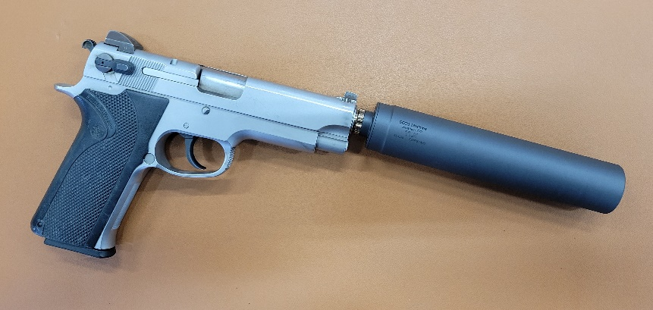
ABOUT THE TLX PISTOL SUPPRESSOR  The TLX is a 9mm or .45 caliber suppressors meant for use on semi-automatic short recoil operated handguns and pistol caliber carbines. It is a fully welded tubeless suppressor with 1.125-28 Alpha threads that will accept direct thread mount or other 1.125-28 Alpha pattern adapters.  USING THE TLX PISTOL SUPPRESSOR  TLX comes with an Ultralight aluminum direct thread mount, which is necessary to keep the weight low enough for “boosterless” cycling on most handguns. Different pistols will have different tolerances for rigid mounted mass on the end of the barrel, and while we have found all tested hosts to cycle with the TLX, some (namely striker fired guns) would not run with certain brands of low powered subsonic ammunition. In the unlikely event that your host weapon will not tolerate the 4.1 ounce (.45 caliber) or 4.3 ounce (9mm caliber) weight of TLX with the included aluminum mount with the ammunition you want to use, TLX can accept our Alpha pattern booster assembly and run pistons.  TLX PISTOL SUPPRESSOR RATINGS  The TLX is constructed of entirely 6Al-4V titanium. The 9mm caliber model is rated for all 9mm caliber & smaller service type handgun cartridges, including .25 ACP, SUBSONIC .300 Blackout, .32 ACP, .380 ACP, 9x19mm, 9x21mm, .357 Sig, .38 Special, .38 Super, SUBSONIC .350 Legend, SUBSONIC 9x39mm, .357 Magnum, and any other cartridges with operating pressure and powder charges not exceeding those of the.357 Magnum. The .45 caliber Model is rated for all of the above, plus 10mm auto, .45 ACP, .45 Super and other cartridges .45 caliber or smaller burning 15 or fewer grains of powder. With 10” or longer barrels, TLX is rated for .44 Magnum, .458 SOCOM SUBSONIC, .45-70 SUBSONIC and similar. TLX is full auto rated with service pistol cartridges. The TLX is NOT approved for use with high velocity centerfire rifle cartridges, and attempting to suppress a rifle with the TLX could result in damage to the suppressor and the host firearm, and injury to the shooter or bystanders. .22 Short, Long and Long Rifle and cast bullet loads should not be used with TLX due to leading of the fully welded non-serviceable suppressor. Rimfires which use jacketed bullets such as .22 WMR and .17 HMR are fine.  . | SERVICING THE TLX  The TLX is a fully welded “tubeless” suppressor and not serviceable, but it may be cleaned with any techniques and chemicals that are safe for stainless steel. If you choose to use any kind of vibratory tubler, though, you must ensure that the media, especially stainless steel pin media, has been removed before using the suppressor again. Ultrasonic cleaning is a safer bet. The Norrell’s Moly Resin finish will hold up to any chemicals or cleaning solutions that won’t also attack the stainless steel. Be sure to remove the aluminum mount before using ultrasonic cleaners or chemicals that are not aluminum safe.

